PRESS RELEASE

COMMUNICATIONS AND MEDIA TEAM OF THE 2023 ASEAN SUMMIT

No.04/SP/TKM-ASEAN2023/ENG/4/2023

Indonesia Prioritizes Food Security in ASEAN-China Cooperation

Beijing, 28 April 2023 – The Indonesian government has determined food security a priority issue in the ASEAN-China Year of Agricultural Cooperation and Food Security launched in Beijing on Tuesday, 25 April 2023.

"As Chair of ASEAN this year, Indonesia views food security as a priority issue," said Indonesian Ambassador to China Djauhari Oratmangun in Beijing on Friday, 28 April 2023.

The former ASEAN Director General of the Ministry of Foreign Affairs of the Republic of Indonesia also had the opportunity to give a speech at the launching of the ASEAN-China Year of Agriculture and Food Security Cooperation.

"We underline the importance of supply chain stability and access to food amidst the current global conditions," said the Ambassador.

Meanwhile, Chinese Premier Li Qiang also gave a speech at the event organized by China's Ministry of Agriculture and Rural Affairs (MARA).

In written remarks read by Deputy Prime Minister Liu Guozhong, Premier Li conveyed his government's commitment to working with ASEAN to strengthen strategic and comprehensive partnerships, particularly in agriculture and food security.

According to him, the program is a starting point for strengthening cooperation, coordination, and communication between ASEAN and China in increasing market access for agricultural products and information exchange and building high-tech agricultural capacity to meet the food needs of two billion people in ASEAN and China.

At the ASEAN-China Summit in November 2022, ASEAN member countries and China agreed to designate 2023 as the ASEAN-China Year of Agricultural Cooperation and Food Security.

The program is part of the ASEAN-China Joint Agreement for Food Security Cooperation.

ASEAN-China trade value in 2022 has reached US$975 billion, specifically for agricultural products reaching US$61 billion.

Both parties will work together in the green agriculture sector, digitizing agriculture and opening market access. (Irfan/TR/Elvira)

***

For more information, please contact:

Director General of Public Information and Communications of the Ministry of Communications and Informatics - Usman Kansong (0816785320)

Get other information at https://infopublik.id

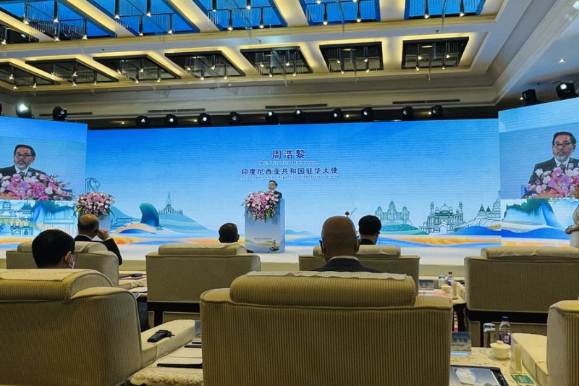

Indonesian Ambassador to China Djauhari Oratmangun speaks at the inauguration of the ASEAN-China Year of Agriculture and Food Security Cooperation in Beijing, Tuesday, 25 April 2023. (ANTARA/KBRI Beijing)

